ATTACHMENT 1
Generator Installation at Owens Valley VLBA Site
Statement of Work

- Scope of Work
  - Background
    - The NRAO has purchased a standby generator set and automatic transfer switch for its remote site at Owens Valley, CA
    - The new equipment will supply backup power to the entire site, replacing the existing backup power system which services part of the site
    - This equipment is expected to be delivered onsite in late spring or early summer
    - This bid is for the installation of this equipment and the removal of obsolete components as detailed in paragraphs 1.2 and 1.3
  - Installation
    - Both the generator set and automatic transfer switch shall be installed near the utility service transformer
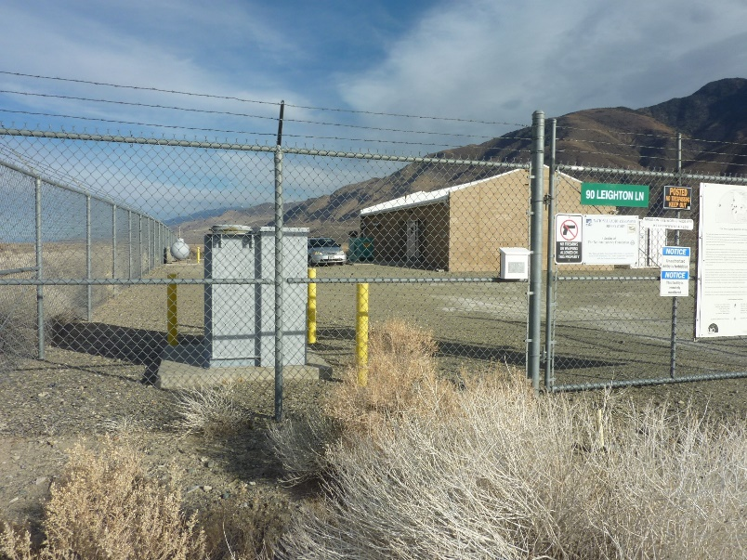
Figure 1: Utility Transformer, side view
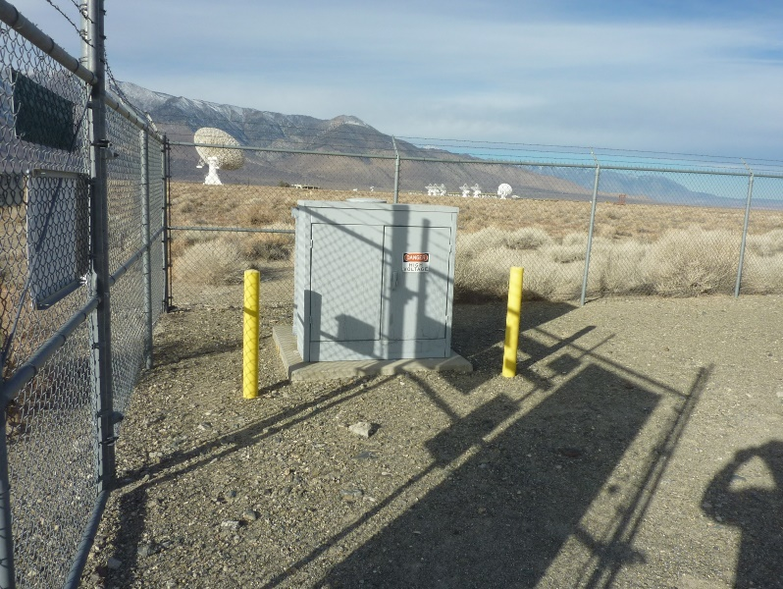
Figure 2: Utility Transformer, front view

    - Both the generator set and automatic transfer switch shall be bolted to a contractor provided concrete slab
    - The transfer switch shall be installed such that it will provide power to the entire facility
    - All new power cabling shall be buried in conduit
  - Removal
    - The existing automatic transfer switch shall be removed from service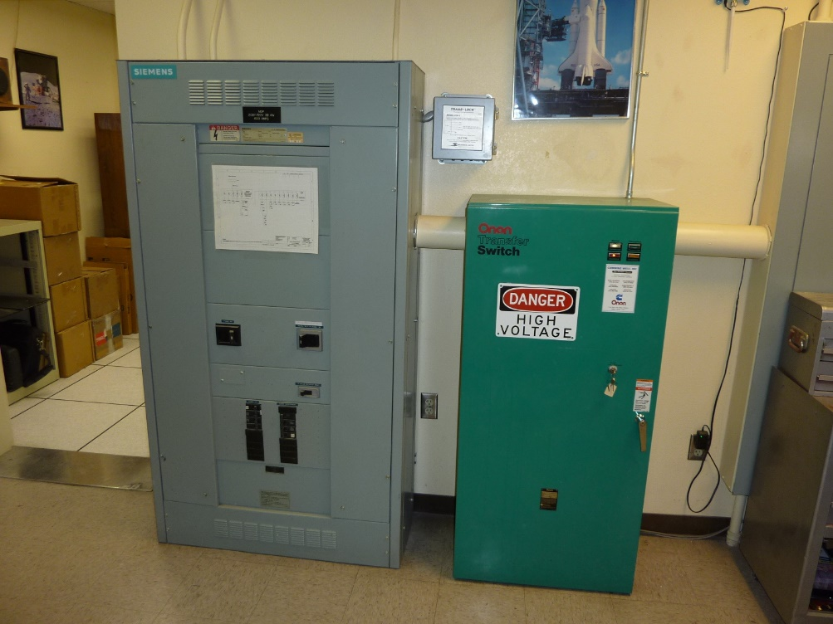
Figure 3: Existing Transfer Switch
    - NRAO staff may choose to salvage some components from the automatic transfer switch prior to its removal
    - New power cabling shall be installed, in conduit, in place of the removed transfer switch
  - Cleanup
    - The contractor shall handle disposal of all waste generated by this project
    - The contractor shall handle disposal of the old transfer switch
- Bid package
  - All bid packages shall include the following:
    - A quote for the work described in paragraph 0
    - A timeline
      - The timeline shall identify:
        - The number of days that the VLBA site is without power
        - The number of days the bidder will be onsite
    - A statement of availability
      - This will identify the dates on which the contractor is available to perform the work described in paragraph 0
and/or
a statement that the contractor will be available provided with (x) weeks’ notice
- Documentation
  - The winning bidder shall provide the following additional documentation:
    - A construction drawing detailing the concrete pad(s) to be poured
    - A drawing/sketch showing the position of the generator set and transfer switch in relation to the existing transformer and building
    - A site specific safety plan
- Jobsite
  - Owens Valley
  - 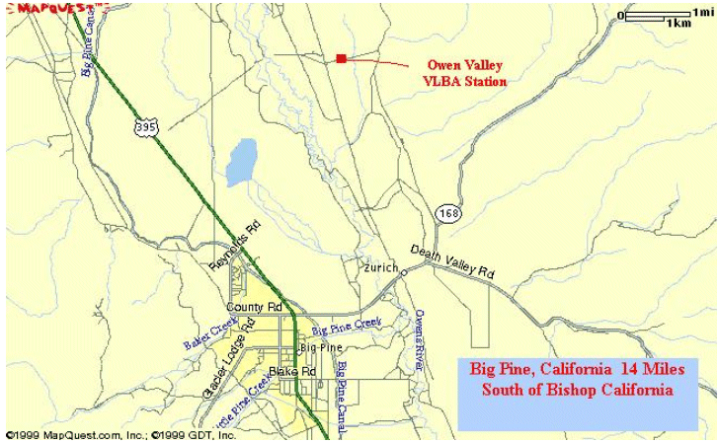
Figure 4: Jobsite Location
  - Site visit
    - Bidders will be allowed a site visit
    - All site visits must be scheduled at least two weeks in advance
    - Restrictions on number of visitors and building access may be imposed due to Covid concerns
    - Activities undertaken during visits shall be documented and approved by the NRAO Covid Management Team prior to travel.
    - Visitors will be required to provide and use appropriate PPE while onsite.
    - All work performed onsite shall comply with current State of California COVID policies
  - Directions: Take US 395 South from Bishop CA. to Big Pine CA. Take highway 168 east for 2 miles, turn left on Leighton Lane (at Zurich historical marker) follow paved road for 3.5 miles. Turn right on gravel road. Follow signs to VLBA antenna
- New equipment
  - Caterpillar C7.1 PGABR Standby Generator Set
    - Standby generator set
    - Fuel type: diesel
    - ISO8528 nameplate: 125kW emergency/standby electrical service
    - 208Y/120 volt, 3-phase, 4-wire, 60hz
    - EPA emission certified for US stationary emergency use
    - Weather protective enclosure - white Sound Attenuated Level 1
    - Integral critical grade exhaust system
    - UL142 closed top double wall fuel tank base; 402 gallon capacity
    - Lockable fuel cap, fuel level gauge & alarms, sender, vents, reliefs
    - EMCP 4.2B electronic modular control panel
    - Modbus RTU communications, configurable accessory I/O, programmable logic control
    - Remote - programmable annunciation panel (supplied loose)
    - UL489 main circuit breaker 400 AF 3-pole LSI electronic100% rated
    - Low coolant level shutdown, low coolant temperature alarm
    - Cat - lead acid engine start battery set, cables, secure mounting tray
    - Charging alternator + multi rate 10A battery charger with NFPA alarms
    - Engine jacket water heater
    - Digital voltage regulator & excitation module
    - Fluid fill; engine oil, engine coolant, battery electrolyte (fuel not included)
    - One round trip provides startup assistance & owner training services
  - Automatic Transfer Switch
    - 208Y/120 volt, 3-phase, 4-wire, 60 hertz Service Ent Rated
    - 400 amp, 3-pole, open transition, contactor type
    - Contactor switching, open transition transfer
    - Non-bypass isolation
    - MX150 digital microprocessor control
    - MEXEG accessory group
    - NEMA 3R outdoor enclosure
- Requests for information
  - For any questions or clarifications, please contact Magdalene Romero (575-835-7200, mromero@nrao.edu)

