How to Copy Data from Excel to Costpoint

- Copy the header from the section you currently working in (this example is Purchase Order Lines, but can also be done with Purchase Requisitions). Navigate to Table View, then select “New” to display a blank record. Click the arrow to select the current row and click “Ctrl-C” to copy the header information. This will copy the row data to a clipboard to paste in Excel. Click “Ctrl-C” to copy the data from the clipboard.
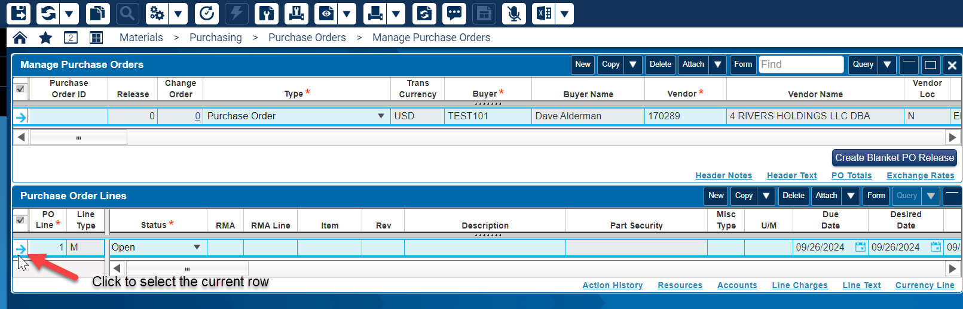
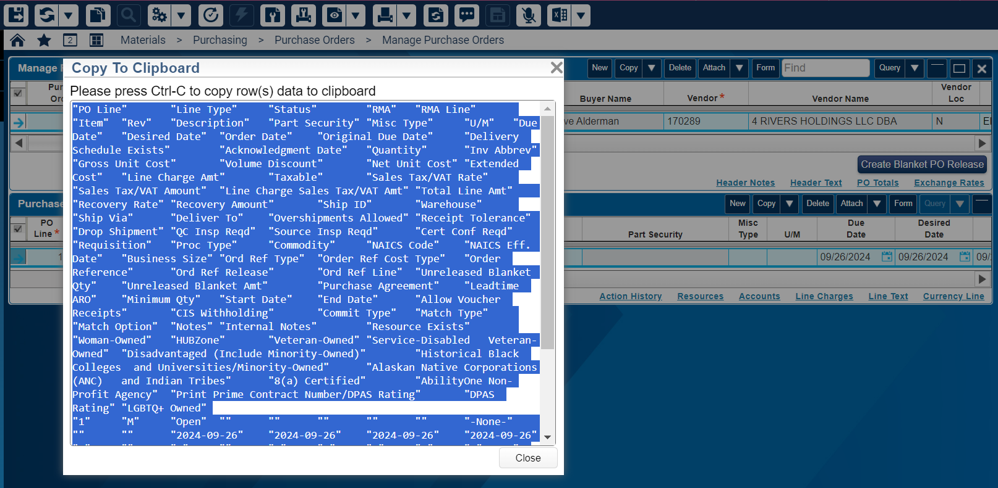

- Paste the copied data to an Excel spreadsheet.
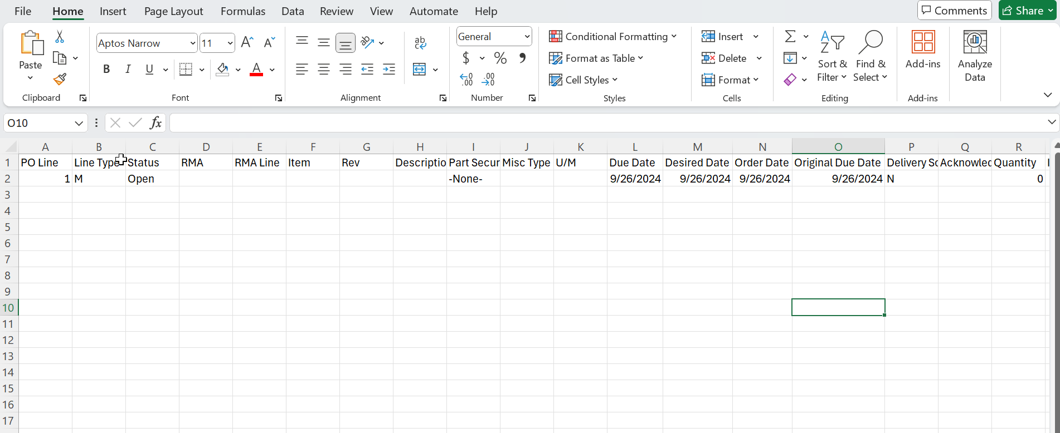
- Enter your requisition data matching the corresponding headers.
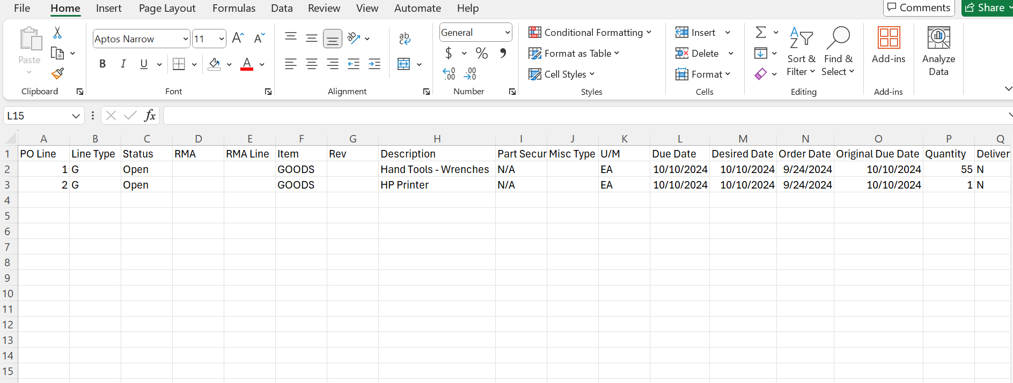

- After entering your data, select all your information excluding the header (Row 1), and copy (Ctrl-C). Avoid including the headers on line 1.
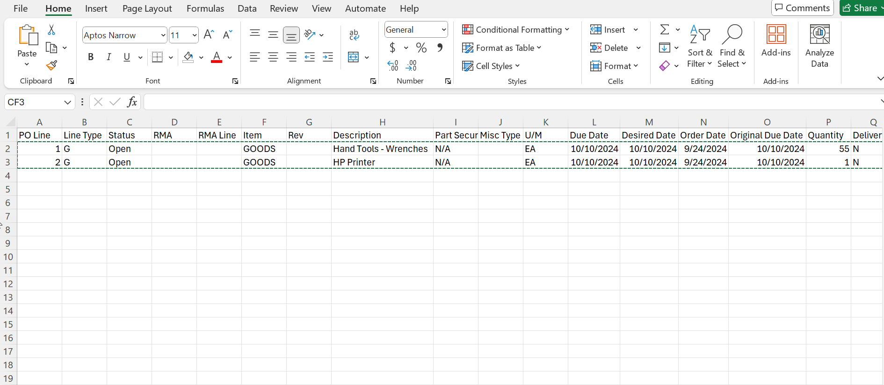

- Now, navigate back to Costpoint, click on the first line’s PO Line (or Req Line) column, and paste your copied data into the first line. You will see the data from Excel is now entered into Costpoint.
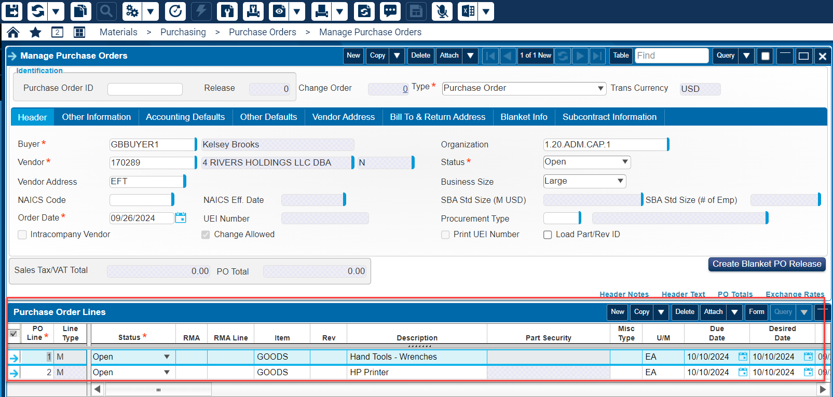
- Save your Purchase Order (or Requisition) once all data is entered.

