First remove your email address
- In Outlook for Mobile, tap the circle in the upper left (It may have your picture or initials 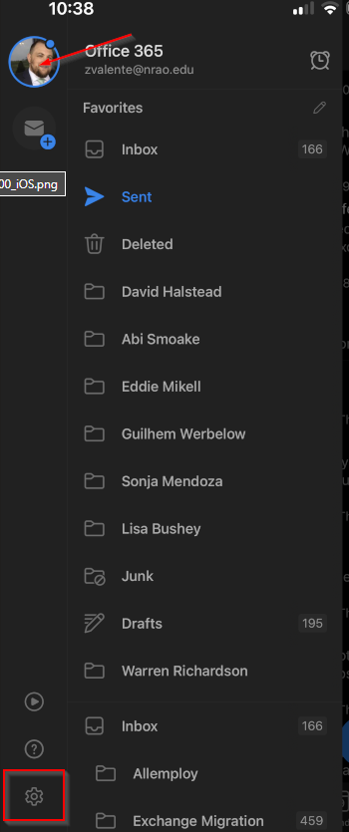
- Under Mail Accounts tap on your NRAO email address 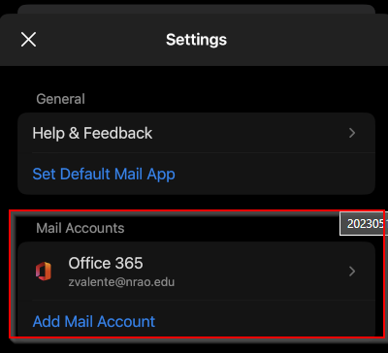
- Tap Delete Account 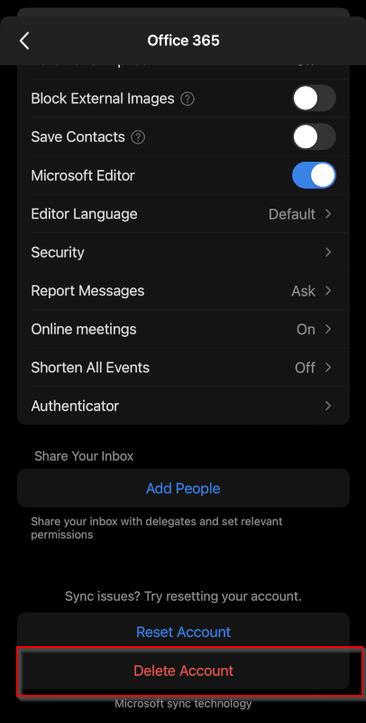
- Tap Delete to confirm removal of your NRAO email account 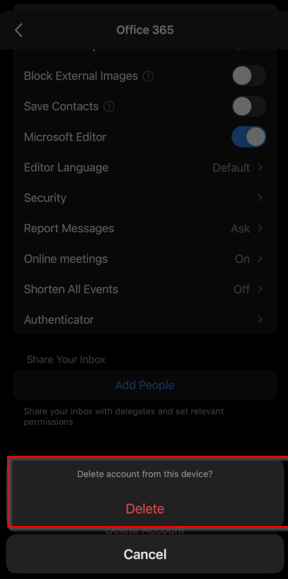

Now re add your NRAO Email Account
- Enter your email address and tap Add Account 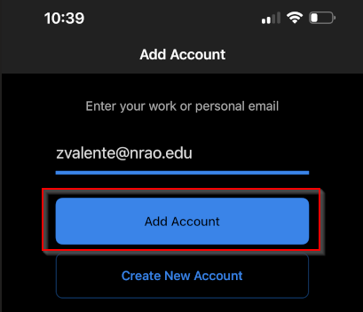
- You will be redirected to authenticate 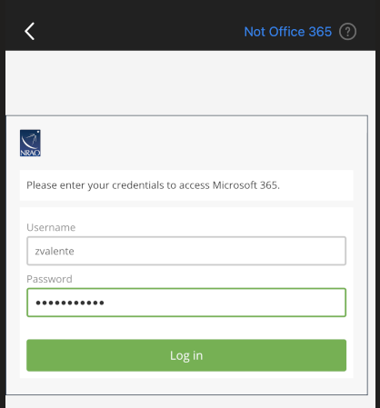
- Choose how you would like to Authenticate 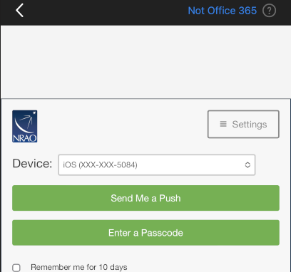
- Tap Maybe Later under Add Another Account 